**AI & DS II Syllabus & Question Bank**

**Unit 1: Uncertainty**

1. Define uncertainty with two examples
2. Mention some of the reason or all reasons for uncertainty
3. Draw the taxonomy of uncertainty
4. What are the different methods to handle uncertainty
5. List down the needs of probabilistic Reasoning in AI
6. Mention the terminologies in probability
7. What do you mean by full joint probability
8. Compute the conditional probability of 𝑃 (𝑐𝑎𝑣𝑖𝑡𝑦/ 𝑡𝑜𝑜𝑡ℎ𝑎𝑐ℎ𝑒) for the table given below

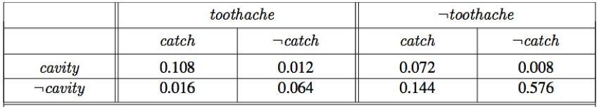

1. In a class, there are 80% of the students who like English and 30% of the students who like English and Mathematics, and then what is the percentage of students who like English, also like mathematics?
2. Write a brief note on Bayes theorem
3. Write down the bayes theorem for any two variables of your choice
4. A doctor is called to see a sick child. The doctor has prior information that 90% of sick children in that neighbourhood have the flu, while the other 10% are sick with measles. A well-known symptom of measles is a rash (the event of having which we denote R).

Assume that the probability of having a rash if one has measles is P (R|M) = 0.95. However, occasionally children with flu also develop rash, and the probability of having a rash if one has flu is P (R | F) = 0.08. Upon examining the child, the doctor finds a rash. What is the probability that the child has measles?

1. Explain Bayesian network in detail with an example with relevant graph
2. List all the events occurring in this network

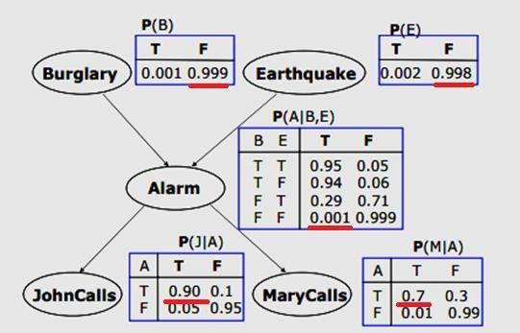

1. Given a hypothesis *h* and data *D* which bears on the hypothesis:

*P* (*h* | *D*) = P (*D* | *h*) *P*(*h*) / *P*(*D*), mention the term for each term in bayes theorem

**Unit 2: Cognitive Computing**

1. What is cognitive computing (CC) and mention the 3 fundamental principles of CC?
2. What are the 3 important concepts that help to design a Cognitive System (CS)?
3. Explain the 3 fundamental principles in a line or two.
4. Give at least two examples or applications of CS.
5. List down all the driving factors of CS.
6. Explain in detail all the features of a CS
7. With help of neat diagram explain all the elements of CS
8. List down all the design principles of CS
9. Explain in detail the design detailing of a CS.
10. Explain with an example Hypothesis generation and scoring during a ML process
11. Discuss how NLP is in support of CS?
12. How can we apply NLP technologies to Business problems
13. Define taxonomy and ontology?
14. Explain in detail how to represent knowledge in taxonomy and ontology
15. Define the components of ontology and give an example f or each
16. Write down the steps to create the ontology of any application
17. What are the different methods to represent the knowledge in CS
18. Write down the steps or process to build the cognitive application

**Unit 3: Fuzzy Logics**

1. Define Fuzzy Logic?
2. Explain all possible Fuzzy Set operation
3. Give some applications of fuzzy logic (FL)
4. Give the difference between fuzzy set ad classic set
5. Explain or write down the equation of a fuzzy logic membership function
6. Draw and explain the architecture of the fuzzy logic system
7. Mention any 5 advantage and disadvantage of FL system.
8. Explain what is fuzzy set theory?
9. What are various shapes of a fuzzy membership function
10. Draw and explain the fuzzy function and all their mathematical derivation for any number of any number of parameters between {0,1}
11. Can the membership function can be chosen at random or based on users experience to represent the set
12. What are the various methods to represent a fuzzy set?
13. List done all the properties of Fuzzy set.
14. Consider these fuzzy sets

A={0.6/a,02/b,0.3/c,0.1/d}

B={0.3/a,0.4/b,0.5/c}

Now perform the operation AUB, A∩B, A’, B’

1. If age is a linguistic variable, then its term set are?
2. How to represent fuzzy relations using matrices.
3. Solve, Let A= B= C= {0,2,4,6}, and the relation R, S, T is defined as follows:

R C A X B, R= {(a, b) | a - b is an even number}}

S C A X B, R= (a, b) | b = (a +3) MOD 2}

T C A X B, R= (a, b) | |a - b|= 2}

1. Using the same fuzzy set-in question 17, try to solve using matrices for TRUS, TR∩S TB’
2. Use the fuzzy set in Question number 17 to solve for Fuzzy Composition
3. Assume that input to a washing machine is weight of clothes, amount of washing powder. Use three descriptors for input variable and 5 descriptors for output variable. Design a fuzzy controller step to determine the wash time of a domestic washing machine.
4. Composition : Find the Dot Product

| **R** | a | b | c | d |
| --- | --- | --- | --- | --- |
| 1 | 0.1 | 0.2 | 0.0 | 1.0 |
| 2 | 0.3 | 0.3 | 0.0 | 0.2 |
| 3 | 0.8 | 0.9 | 0.1 | 0.4 |

| **S** | **𝛂** | **𝜷** | **𝛄** |
| --- | --- | --- | --- |
| a | 0.9 | 0.0 | 0.3 |
| b | 0.2 | 1.0 | 0.8 |
| c | 0.8 | 0.0 | 0.7 |
| d | 0.4 | 0.2 | 0.3 |

1. 1) Find the compliment  
    A = { ((x,0.5) (x,0.7) (x,0) }  
   2) A = { 1.0 , 0.20 , 0.75 }  
    B = { 0.20, 0.45 , 0.50 }  
   find : (i) A U B (ii) A ⋂ B
2. Given : : S = { (0 , 0 ) ( 0, 2 ) (1 , 1 ) ( 1 , 3 ) ( 2 , 0 ) ( 2, 2 ) ( 3 , 1 ) ( 3 , 3 ) }  
    S = { (0 , 2 ) ( 1, 0 ) ( 2, 1 ) (3 , 2 ) }  
   Find : (i) R U S (ii) R ⋂ S
3. Given : : S = { (0 , 2 ) ( 1, 0 ) ( 2, 1 ) ( 3 , 2 ) }  
    T = { (0 , 1 ) ( 1, 2 ) ( 2, 3 ) ( 1 , 0 ) ( 2, 1 ) (3 , 2 ) }  
   Find : (i)S U T (ii) S ⋂ T
4. Find the composition of fuzzy set A & B

| **A** | a | b | c |
| --- | --- | --- | --- |
| 1 | 0.5 | 0.0 | 0.0 |
| 2 | 0.45 | 0.2 | 0.0 |
| 3 | 0.0 | 0.7 | 0.0 |

| **B** | a | b | c |
| --- | --- | --- | --- |
| 1 | 0.3 | 0.0 | 0.0 |
| 2 | 0.2 | 0.0 | 0.0 |
| 3 | 0.0 | 0.0 | 0.9 |